MSI Project: Generation of a molecule's crystal copies

Authors: M. Emezue, J. F Gilabert & A. Marín

Objective:

The objective of this project is to generate a Python code which allows the user to generate the crystal copies of a protein's structure which are stored in a PDB file. Molecule information is stored in a “Molecule” object from the htmd package and the structures are visualized using VMD.

Code explanation:

The code is organized in three different classes with their corresponding methods.
- class MoleculeCopy:
This class has different methods which allow placing each crystal copy of the molecule in the same unit cell (the one placed at the origin).
  - get_mean_center: It computes the mean center of the MoleculeCopy instance.
  - get_cellloc: It takes into account beta and gamma angles to correct X axis boundaries and correctly determine in which cell the copy is originally placed.
  - is_outside: It checks if a crystal copy is placed in the target unit cell or not and returns a Boolean output (True/False). It also calls the method get_cellloc and stores the result into the attribute self.cellloc.
  - move_inside: It changes the center of the crystal copy to place it inside the target unit cell. The translation to be applied consists in the substraction of the origin of the initial unit cell (the one where the copy is placed) to the center of the copy.
  - place_crystal: If the copy is outside of the target unit cell (verified by is_outside method), it calls the move_inside method to place the copy into the correct unit cell.
- class UnitCell:
This class uses different methods to generate the crystal copies of the molecule and allows visualization. It creates an htmd.Molecule object and reads all necessary information from the PDB to represent these crystallographic structures.
  - readPDB: It reads the PDB file of a Molecule and stores all angles and axis lengths which are necessary for the calculation of the molecule's copies coordinates. If the PDB does not contain crystallographic information, it raises an exception of class PDBError.
  - get_size: It computes maximum coordinates of the target unit cell in all axes.
  - draw_cell: It uses the angles and axes to draw the lines which define the target unit cell. If the unit cell is hexagonal, it gets the information from the PDB and calls the build_hexagon method.
  - build_hexagon: It allows to draw the outline of an hexagonal cell unit.
  - draw_copies: It creates a MoleculeCopy instance for each crystallographic copy and applies crystal symmetry operations to it. Afterwards, it calls to method place_crystal and to place the copy into the target unit cell. Finally, it appends all copies to the same htmd.Molecule object.
  - view_unit_cell: It allows representation of the crystallographic copies and the outline of the unit cell using VMD.
- class PDBError:
This class is a child of the Exception class. UnitCell class raises an error of this type if the PDB does not contain crystal information. This hapens when the experimental technique used to acquire data (“EXPDTA” from PDB) is not “DIFFRACTION” or “CRYSTAL”. This way of telling whether a structure was obtained from crystallographic means can fail, though. In case a PDB file does contain information on crystallographic structure and so long as information on the symmetry matrix exists inside the file with the appropriate nomenclature, then the record “EXPDTA” can be modified in order to obtain this information.

The name of the file is selected by changing the field filename = “” which can be found in line 244. The absolute or the relative path to the desired file must be introduced.

If a representation different than “NewCartoon” is preferred, visualization style can be changed in line 245.

In the case of an hexagonal unit cell, lines 246 and 247 can be modified (set to True) in order to represent the unit cell and the copies using an hexagonal representation. If the parameters are set to False, the cell unit will be represented as an hexahedron, which is the output that can be visualized by using Chimera. In this sense, we are capable of both visualizing the rhomboid primitive cell or the hexagonal unit cell depending on our needs.

Do note that if these parameters are set to True for a non-hexagonal unit cell, the output won't change. This happens because upon reading the PDB file, an inner flag is stored telling whether a structure is hexagonal or not, so even if the switches are set to True, operations won't be performed. In fact, even if the hexagon unit cell is built, it is possible to retrieve the rhomboid representation since it is not overwritten, but rather a new attribute of the UnitCell instance with the hexagonal representation is created (hexagonal_molunit).

Program flow:

The user only needs to set up filename attribute (line 244) and the corresponding switches (draw_crystal_type and full_build, lines 246 and 247) variables explained above in order to properly run the code.

First, a UnitCell instance is set up with the PDB file specified by the path in “filename”. Then, the cell is drawn with UnitCell's method draw_unit_cell, which requires a boolean variable as an argument. Lastly, molecule copies are placed inside the cell with UnitCell's method draw_copies. At this point, the only thing left is to visualize the htmd molecule instance created with the crystal representation, done with UnitCell's method view_unit_cell, which takes as an argument VMD's representation; in the sample code, this is given through display_type (line 245), set to 'NewCartoon'.
Examples:

1) 3v03

3v03 is a protein structure with four repetitions within a rhomboid unit cell. As we can see below, our program's representation matches that of Chimera.

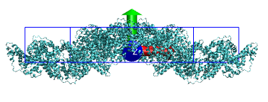
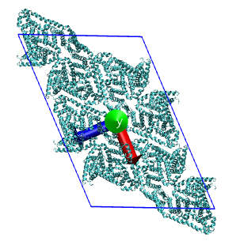
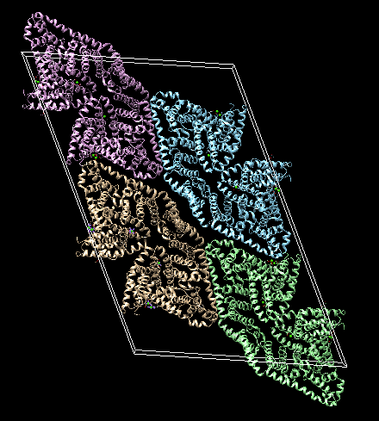

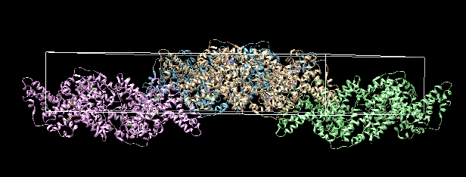

In this case, whether the switches that allow for a hexagonal visualization are set to True or not does not matter, since the cell unit does not correspond to a hexagon.

2) 1rxb

1rxb corresponds to a RNA molecule inside a hexagonal unit cell with 18 copies. In this case, we will compare our results with those of Chimera, which can be done by setting both switches to false, and then see what happens when either or both of them are set to 'True', since in this case, we will see the differences.
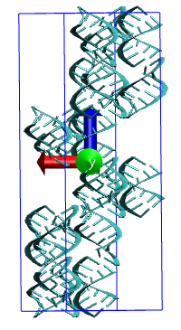
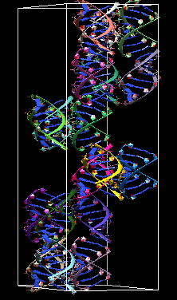

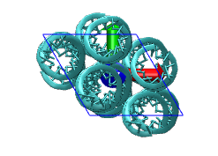
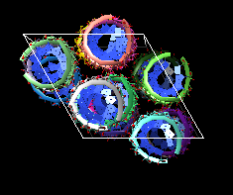

It is easy to see at a glance that both our results and Chimera's visualization are quite similar, to the point each RNA molecule represented in Chimera can be seen occupying a place in our representation. It is not entirely accurate to say that our results perfectly match those of Chimera, but at least it seems that way.

By setting draw_crystal_type to 'True', the output we visualize is:
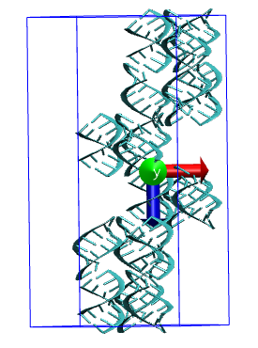

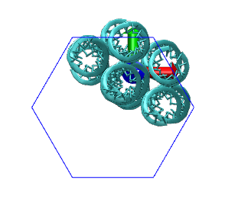

As we can see, the molecule copies are comparable to those obtained with Chimera above, yet the cell's boundaries do not correspond to the primitive cell, but rather to the hexagonal lattice. This is done by only rotating twice the boundaries and then not doing the same to the molecule copies.

Next, if we set to 'True' full_build, the result that we get is the following:

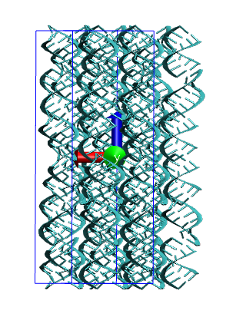

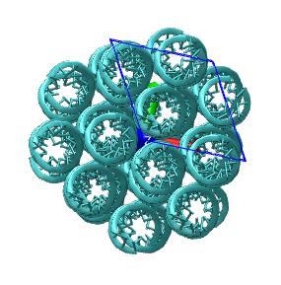

As we can see, the resulting molecule instance has represented the rhomboid boundaries, just like Chimera, but the molecule copies are arranged in a hexagonal way, which is accomplished by rotating by 120 degrees twice the molecule copies without arranging the boundaries.

Lastly, if we set them both to 'True', we get the following representation:
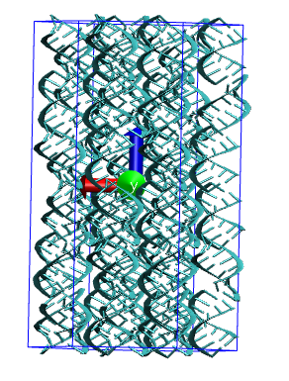
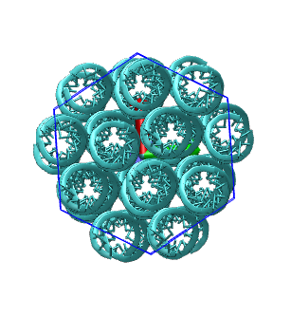

As we can see, what we get is the result of combining the previous two outputs; in other words, rotating by 120 degrees twice both the boundaries of the primitive cell and the molecule copies.

As we can see, when neither of the switches are set to 'True', the results are fully comparable with those of Chimera; at a glance, we can see that both of them are pretty much the same, but in order to be sure, a superposition of both structures and computation of their RMSD is needed. As for the cases when either switch or both of them are 'True', then comparisons with Chimera lose meaning since its visualization does not match with ours. However, at a glance, we can see that in these case, the entirety of the hexagon is occupied because those RNA molecules which in one primitive cell occupy what we see in these images as the top-right of one primitive cell partially occupy the top-left of the contiguous unit-cell and the same happens with those at the bottom-left occupying the bottom-right of the adjacent unit-cell.

3) 1joy

This last example corresponds to a non-crystallographic structure, since it was obtained through NMR. As such, what we expect upon running the program is that it returns a PDBError, indicating the means by which the structure was obtained.

Concluding remarks:

As we can see from the examples we have run, the provided code properly builds a unit cell and places molecule copies inside it accordingly. More tests than the ones provided in this document have been performed, and the results are the same. However, it remains to be seen if this is the case for more crystallographic structures found in PDB.

Regarding the code itself and its performance, its running time scales with the amount of atoms the molecule instance has, as well as with the number of molecule copies within the unit cell. However, this scaling is barely noticeable unless the amount of copies is really large and no way to further optimize speed could be found. A valid point to raise is the fact that PDB information is retrieved not by character position, which is the standard when it comes to PDB file handling, but rather by string position (separator dependant). Nonetheless, this has not proven troublesome in the test runs, so whether or not is an issue remains to be seen.

The code's limitations as of now imply: not handling non-symmetric structures and poor flexibility when it comes to detecting whether a structure is of crystallographic origin or not, since it depends on finding either 'CRYSTAL' or 'DIFFRACTION' in the corresponding PDB remark.

In conclusion, the code's performance seems to be very good and the results are satisfactory. Yet it is still possible to extend its capabilities further.

